Lê Anh Phong – DCCNTT 13.10.10
20222010 – Đề chẵn: Vẽ giá sách
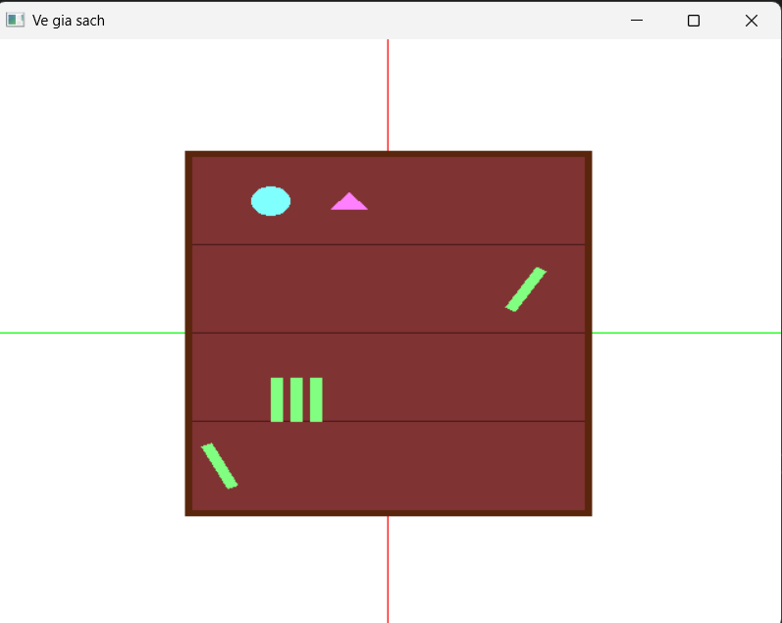

#include <stdio.h>
#include "glut.h"
#include "math.h"

void DrawCoordinate() {
// Trục X - xanh lá
glColor3f(0.0, 1.0, 0.0);
glBegin(GL_LINES);
glVertex3f(-1.0, 0.0, 0.0);
glVertex3f(1.0, 0.0, 0.0);
glEnd();

// Trục Y - đỏ
glColor3f(1.0, 0.0, 0.0);
glBegin(GL_LINES);
glVertex3f(0.0, -1.0, 0.0);
glVertex3f(0.0, 1.0, 0.0);
glEnd();
}

void RenderScene() {
glClear(GL_COLOR_BUFFER_BIT);
glLoadIdentity();
DrawCoordinate();

glColor3f(0.35, 0.15, 0.05);
glBegin(GL_QUADS);
glVertex2f(-0.52, -0.62);
glVertex2f(0.52, -0.62);
glVertex2f(0.52, 0.62);
glVertex2f(-0.52, 0.62);
glEnd();

glColor3f(0.5, 0.2, 0.2);
glBegin(GL_QUADS);
glVertex2f(-0.5, -0.6);
glVertex2f(0.5, -0.6);
glVertex2f(0.5, 0.6);
glVertex2f(-0.5, 0.6);
glEnd();

glColor3f(0.3, 0.1, 0.1);
glBegin(GL_LINES);
glVertex2f(-0.5, 0.3); glVertex2f(0.5, 0.3);
glVertex2f(-0.5, 0.0); glVertex2f(0.5, 0.0);
glVertex2f(-0.5, -0.3); glVertex2f(0.5, -0.3);
glEnd();

glColor3f(0.5, 1.0, 1.0);
float cx = -0.3, cy = 0.45, r = 0.05;
glBegin(GL_POLYGON);
for (int i = 0; i < 50; i++) {
float theta = 2.0f * 3.14159f * i / 50;
glVertex2f(cx + r * cos(theta), cy + r * sin(theta));
}
glEnd();

glColor3f(1.0, 0.5, 1.0);
glBegin(GL_TRIANGLES);
glVertex2f(-0.1, 0.48);
glVertex2f(-0.15, 0.42);
glVertex2f(-0.05, 0.42);
glEnd();

glPushMatrix();
glTranslatef(0.35, 0.15, 0);
glRotatef(-30, 0, 0, 1);
glColor3f(0.5, 1.0, 0.5);
glBegin(GL_QUADS);
glVertex2f(-0.015, -0.08);
glVertex2f(0.015, -0.08);
glVertex2f(0.015, 0.08);
glVertex2f(-0.015, 0.08);
glEnd();
glPopMatrix();

glPushMatrix();
glTranslatef(-0.43, -0.45, 0);
glRotatef(25, 0, 0, 1);
glColor3f(0.5, 1.0, 0.5);
glBegin(GL_QUADS);
glVertex2f(-0.015, -0.08);
glVertex2f(0.015, -0.08);
glVertex2f(0.015, 0.08);
glVertex2f(-0.015, 0.08);
glEnd();
glPopMatrix();

float xStart = -0.3;
for (int i = 0; i < 3; i++) {
glColor3f(0.5, 1.0, 0.5);
glBegin(GL_QUADS);
float x1 = xStart + i * 0.05;
glVertex2f(x1, -0.3);
glVertex2f(x1 + 0.03, -0.3);
glVertex2f(x1 + 0.03, -0.15);
glVertex2f(x1, -0.15);
glEnd();
}

glutSwapBuffers();
glFlush();
}

void init(void) {
glClearColor(1.0, 1.0, 1.0, 1.0);
glOrtho(-1.0, 1.0, -1.0, 1.0, -1.0, 1.0);
}

void main() {
glutInitDisplayMode(GLUT_DOUBLE | GLUT_RGB);
glutInitWindowSize(640, 480);
glutInitWindowPosition(100, 100);
glutCreateWindow("Ve gia sach");
init();
glutDisplayFunc(RenderScene);
glutMainLoop();
}

